**EXPERIMENT 8**

**SAILOR BOAT DATABASE (DDL, DML, DQL, Subquery, Joins, Set operations)**

**Aim:**

• Create sailors, boats, and reserves.(foreign key)

• Insert 5 values each table.

• Display all records.

• Find the names and ages of all sailors.

• Find all sailors with ratings above 8.

• Find sailors name with rating above 7 & age above 25.

• Display all the names & colours of the boats.

• Find all the boats with Red colours.

• Find the names of sailors' who have reserved boat number 103.

• Find the sids of sailors who have reserved blue boat

• Find the names of sailors' who have reserved Red boat.

• Find the colours of boats reserved by some name(provide any name in table).

• Find the names of the sailors who have reserved at least one boat.

• Find the names of the sailors who have reserved two different boats.

Find the names of sailors who have reserved a Red or a Green boat.(union)

• Find the names of sailors who have reserved both a Red and a Green boat.

• Find the names of sailors who have reserved boat 103.(nested query)

• Find the names of sailors who have reserved red boat.(nq)

• Find the names of sailors who have not reserved red boat.(nq)

• Find the names of sailors who have reserved boat number 103.(exists)

• Find sailors whose rating is better than some sailors called name.

• Find sailors whose rating is better than every sailor' called name.

• Find the sailors with highest rating.

• Find the average age of all sailors.

• Find the average age of sailors with a rating of 10.

• Count the number of sailors.

• Count the number of different sailor ratings.

• Find the name and age of the oldest sailor.

• Find the names of the sailors who are older than the oldest sailor with a rating of 10.

• Find the age of youngest sailor for each rating level.

• Find the age of the youngest sailor who is eligible to vote (i.e., is at least 18 years old) for each rating level with at least two such sailors.

• For each red boat, find the number of reservations for this boat.

• Find all sailors name according to names.

• Find all sailors details according to rating.

• Find all sailors details according to rating(highest first) if ratings are same then according to age(youngest first).

**CREATE SCHEMA sailors;**

1.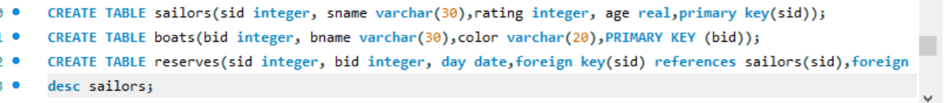

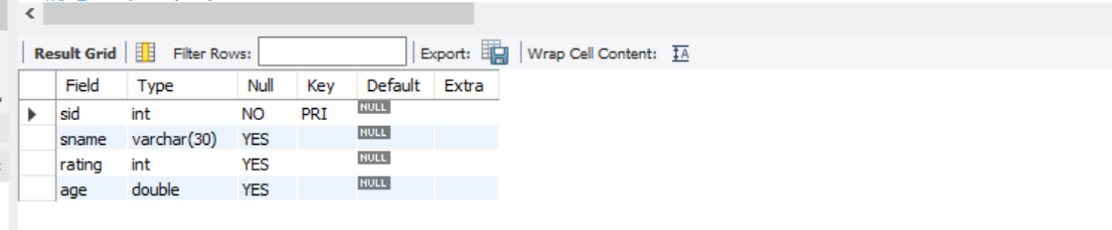

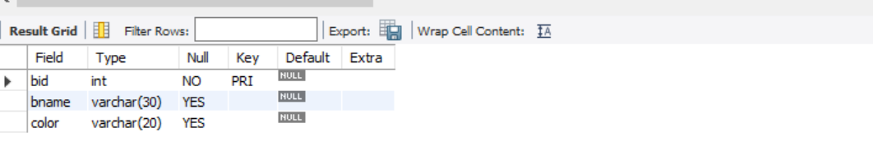

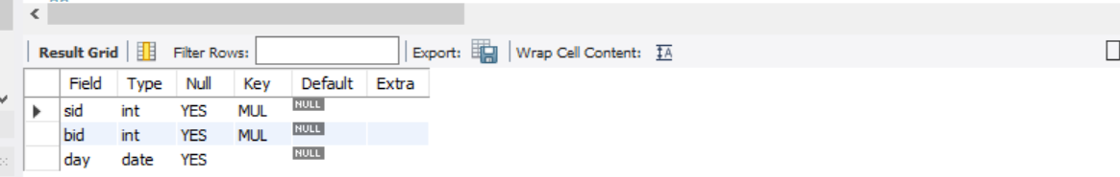

2.

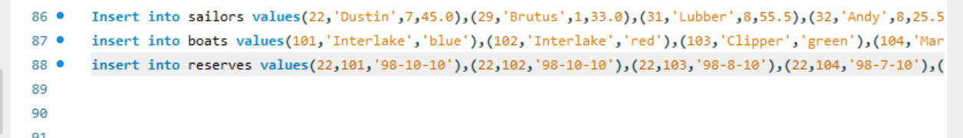

3.

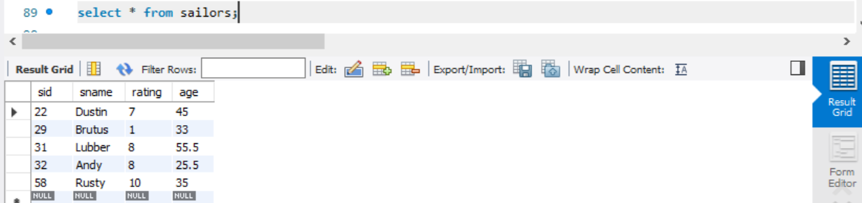

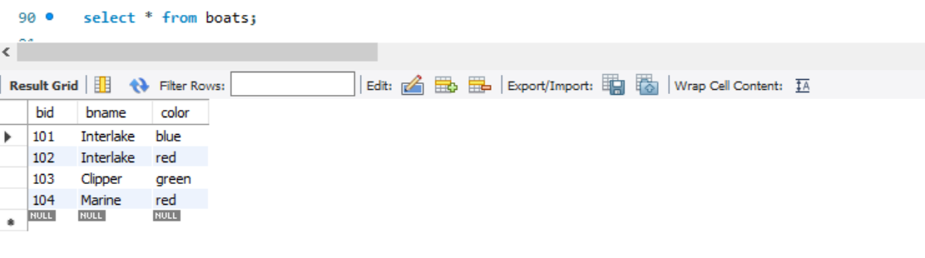



4.

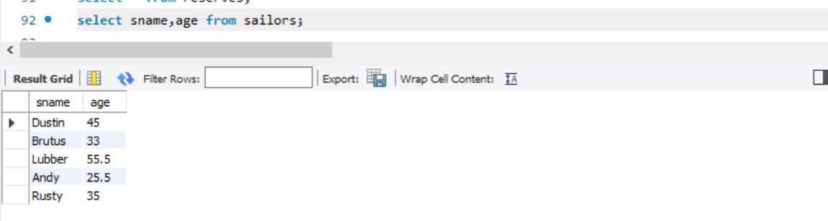

5.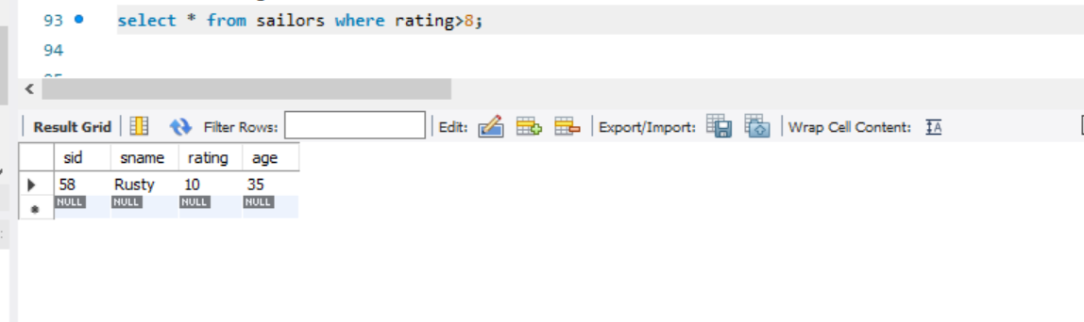

6.

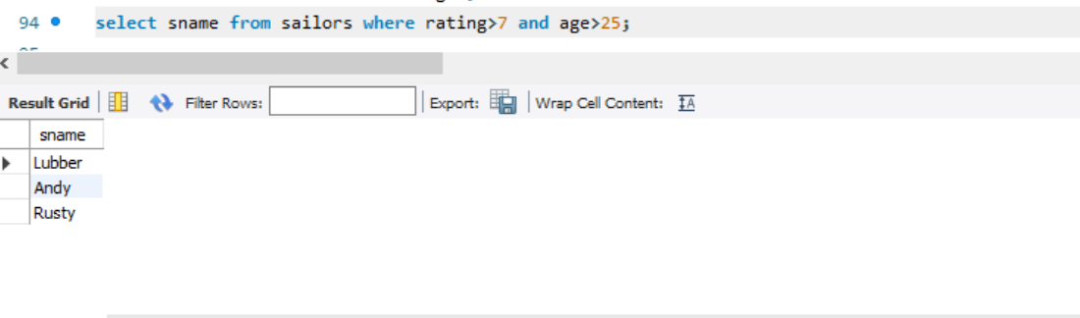

7.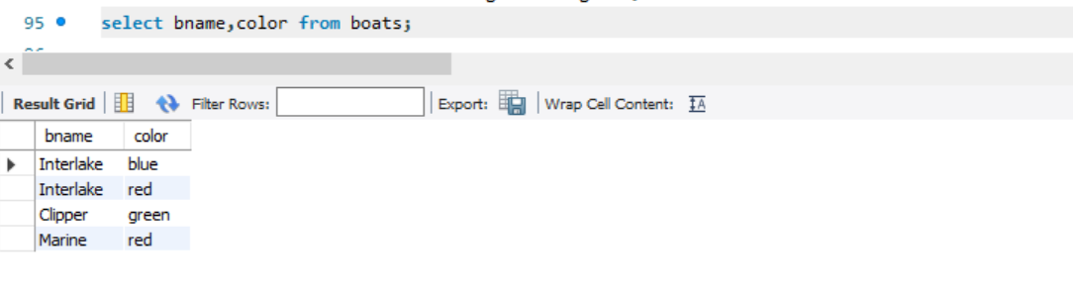

8.



9.

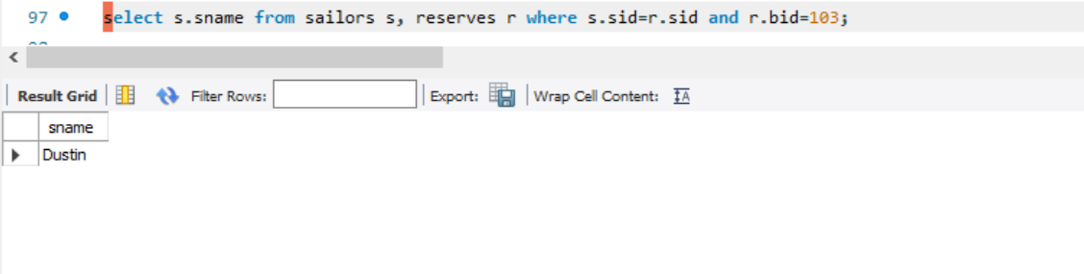

10.

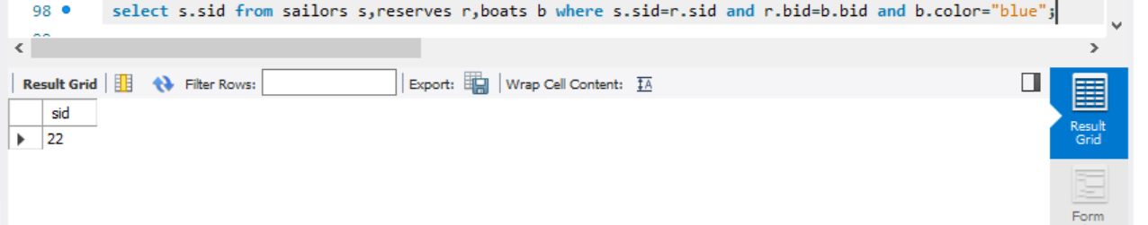

11.

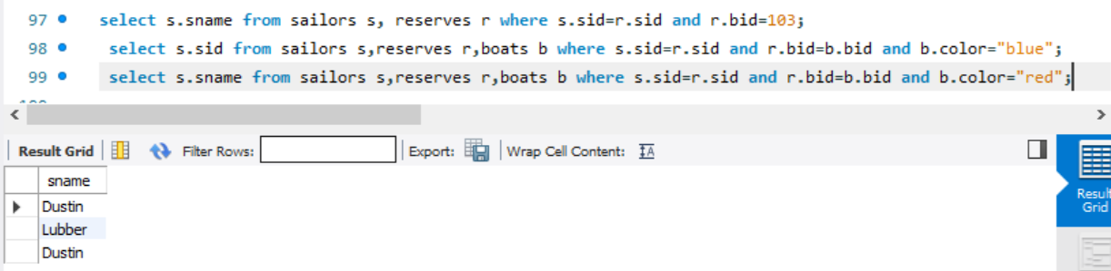

12.

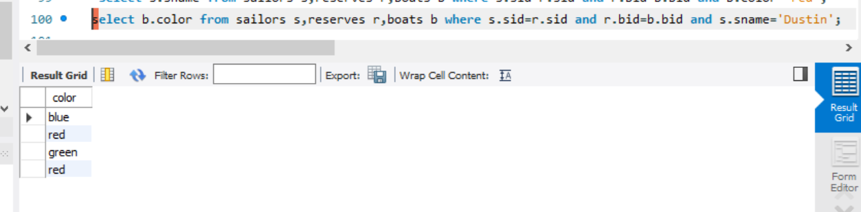

13.

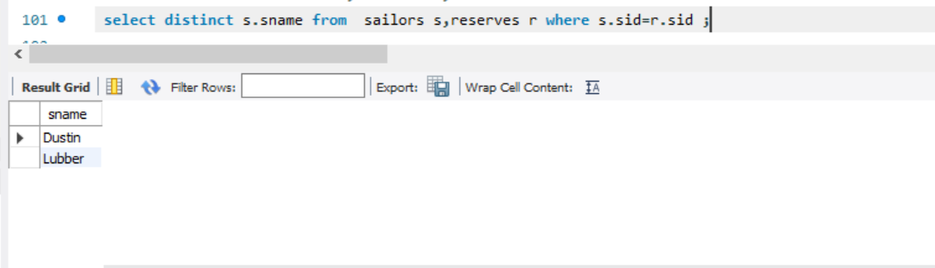

14.

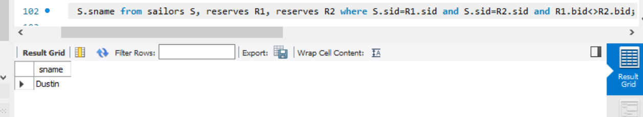

15.

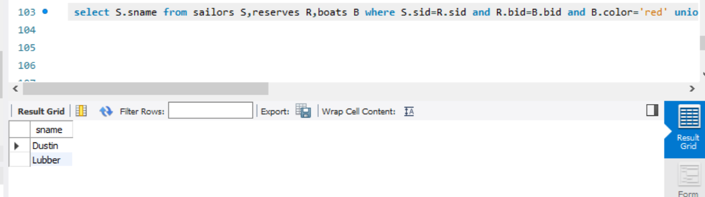

16.

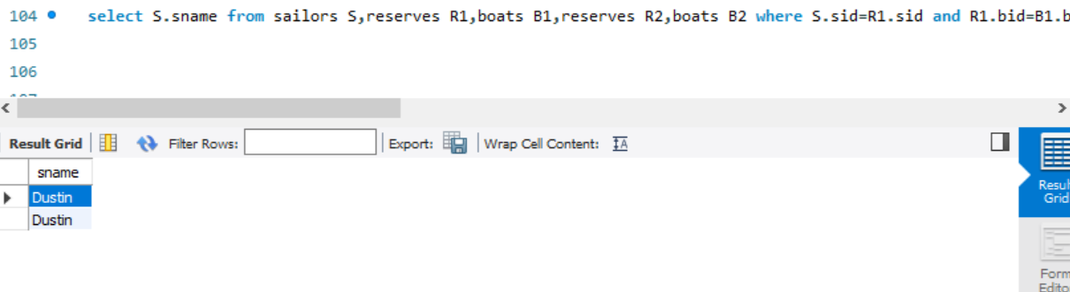

17.

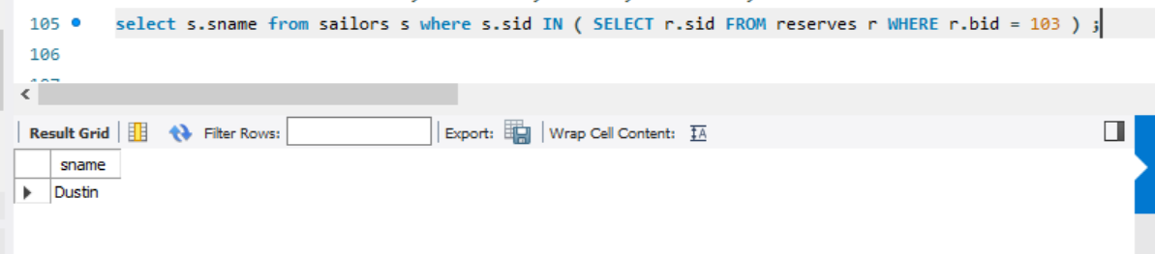

18.

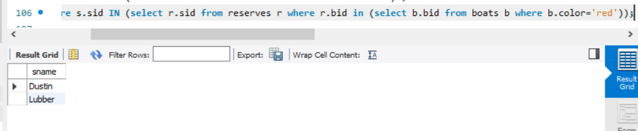

19.

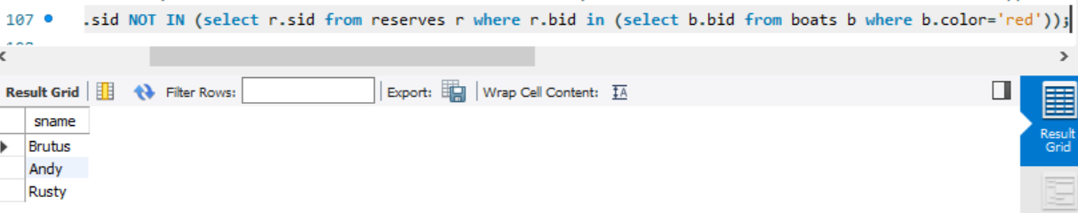

20.



21.

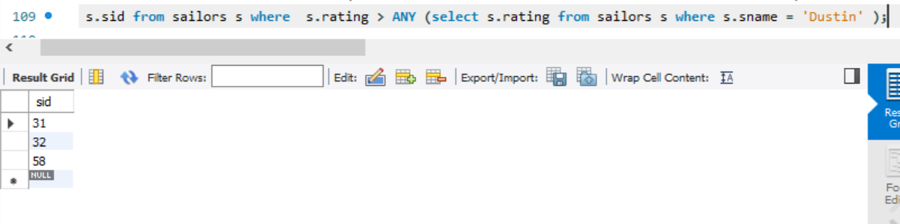

22.

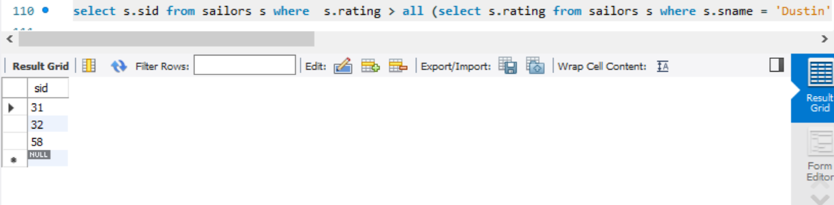

23.

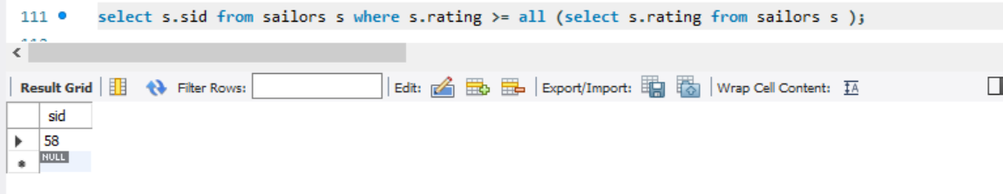

24.

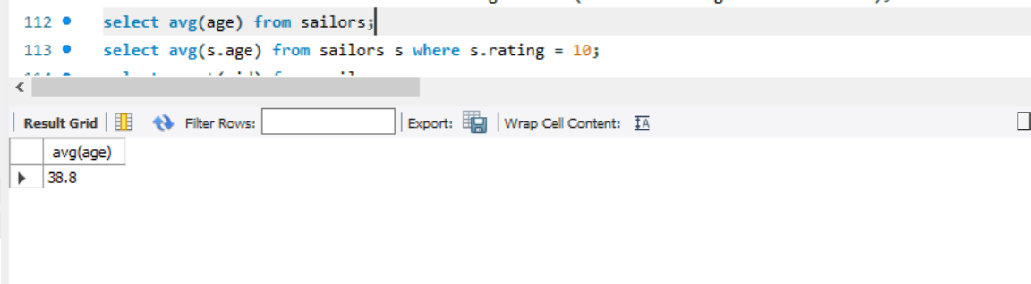

25.

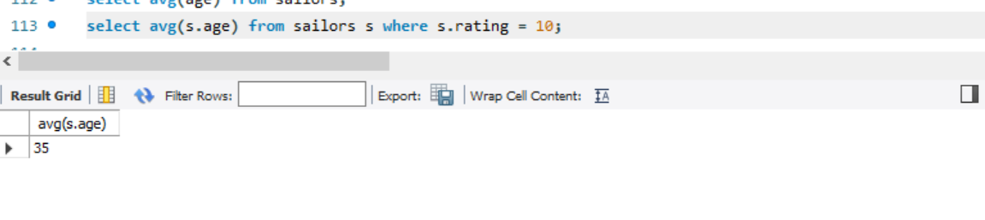

26.

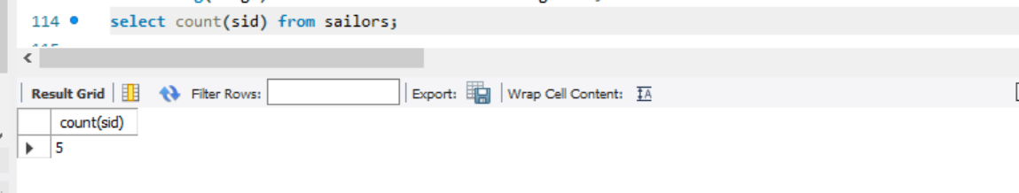

27.

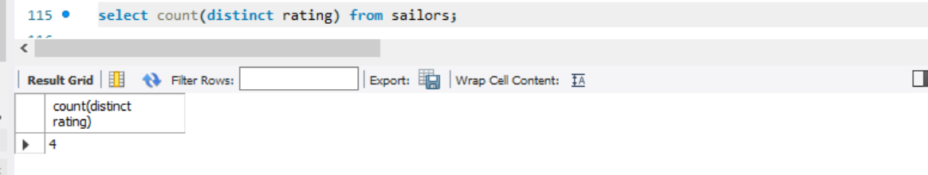28.

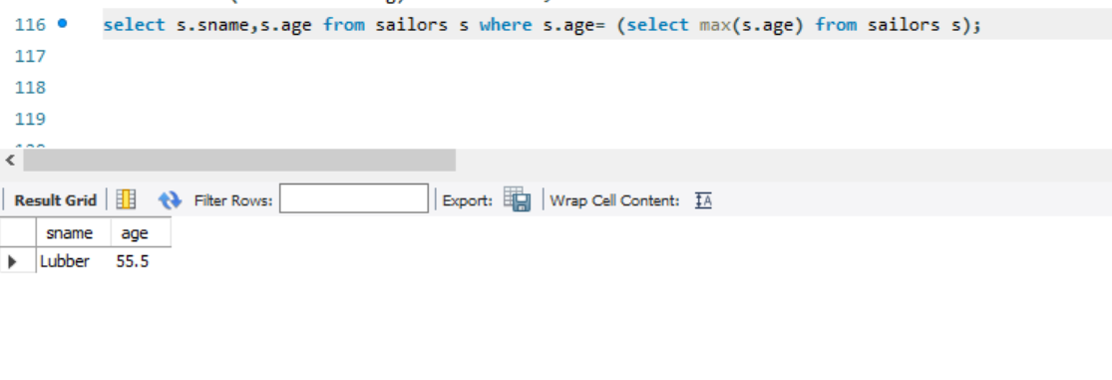

29.

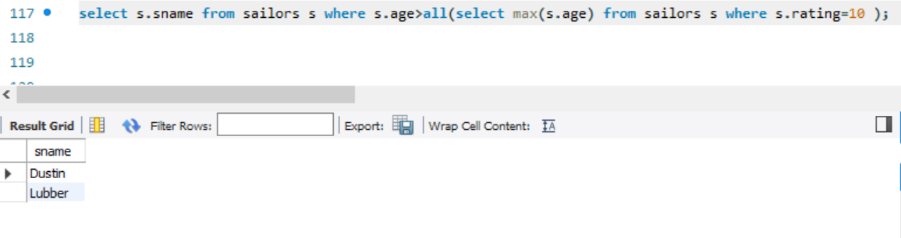

30.

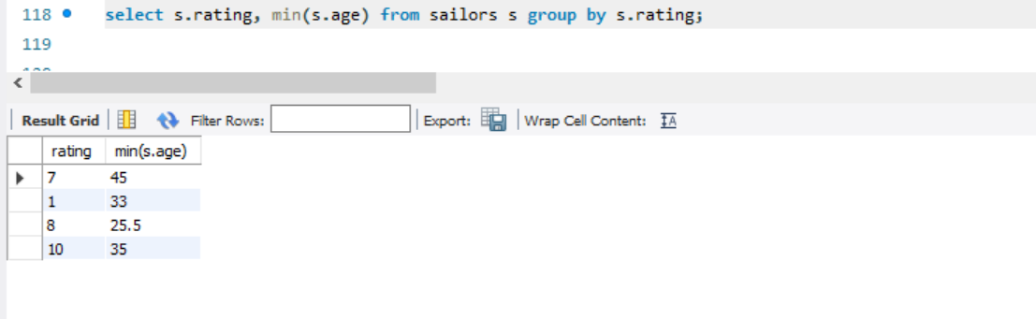

31.

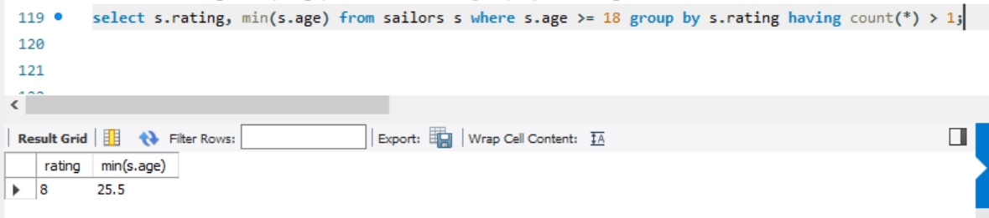

32.

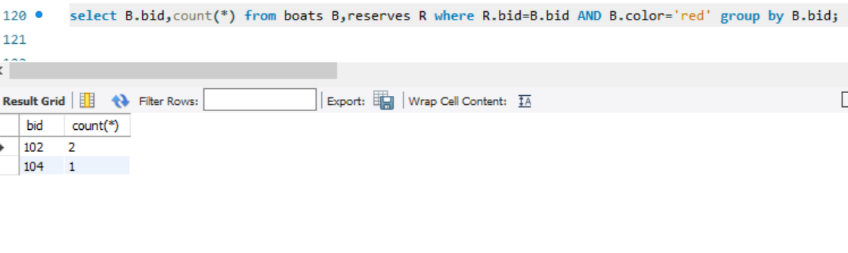

33.

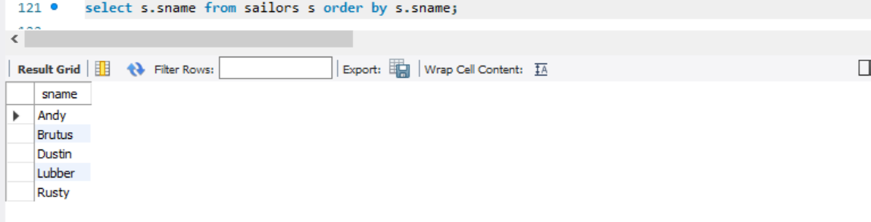

34.

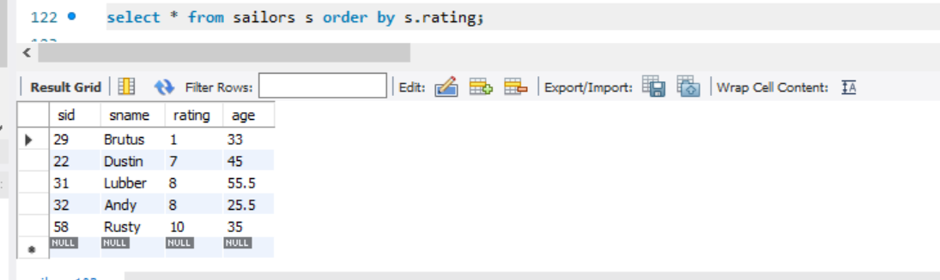

35.

